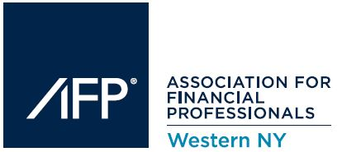
The AFP of Western New York presents its
2017 March Lunch Meeting

Wednesday, March 8th, 2017
Located at:
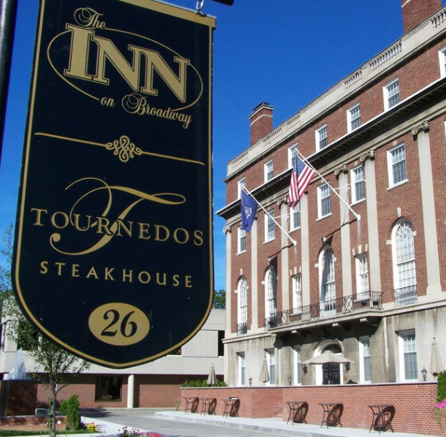
Tournedos Steakhouse
26 Broadway, Rochester, NY 14607 (585) 269-3888

THE ASSOCIATION FOR FINANCIAL PROFESSIONALS OF WESTERN NY
The Association for Financial Professionals of Western New York is a non-profit, educationally oriented organization, which provides a forum for the active and open exchange of concepts and techniques related to the practice of cash and treasury management. Today’s membership represents a wide cross section of local industry professionals. Membership is open to individuals from businesses and non-profit organizations, financial service vendors and banks. A free flow of ideas and information is encouraged and maintained among the Association’s members.
Each year, the AFPWNY bases its education program decisions on participant response to the previous year’s programs. This process ensures that topics addressed during each seminar reflect the most prevalent issues, and that the information provided is on leading edge technologies. Conference attendance continues to flourish resulting from feedback received from attendees.
AFPWNY encourages member participation in the National Association for Financial Professionals (AFP). In addition to offering a wide range of continuing education opportunities, professional certification and industry standards programs, the AFP has become an invaluable resource for disciplines represented in organizational and corporate treasury areas. Together with affiliate organizations, AFP works to increase professional skills and to enhance the recognition and credibility of the treasury management profession.
Program Registration & Lunch: 11:30 AM – 2:00 PM
Lunch will be provided around noon. Come early, it’s a great chance to network!

Presentation: 12:30 PM – 1:45 PM

Topic: Predictive Cash Forecasting and Intuitive Bank Connectivity
Speaker: Thomas Leitch, Vice President TreasuryXpress – Americas and UK

For the past decade, Treasury Management technology has been relatively stagnant in its evolution to the next phase. For nearly a decade, treasury articles around the world headlined: “The New Normal.” But did it ever get here? And if it did, how did it really advance how treasurers worked?

While technology has advanced and become more accessible and affordable for other business units such as sales, marketing, or human resources, treasury teams have been glaringly overlooked as beneficiaries of innovation. Not any longer. To stay competitive, treasurers need to embrace the importance of the digital trends shaping the financial world and learn to harness this innovation.

Treasury Management systems are no longer tools that just provide automation, audit and visibility, but are now starting to empower treasurers with real time connectivity, collaboration, predications, and scalability. The utilization of emerging technology and services has now begun to truly democratize the TMS world, allowing all treasurers to utilize technologies on the market.

Additionally, today’s FinTech innovations are disrupting the banks monopoly over services to provide best practices, utilize API’s around connectivity and payments, and show how the advent of the treasury market place is allowing treasurers to enhance current systems to reduce disruption and cost.

Speaker Information:

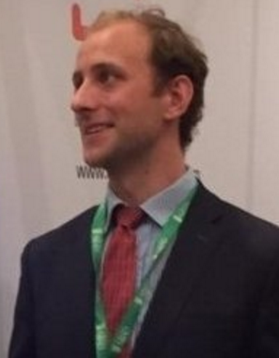

Thomas Leitch
Vice President TreasuryXpress – Americas and UK

Tom Leitch currently serves TreasuryXpress as the VP of the Americas and UK. With a background deeply rooted in the treasury and financial industry, Tom provides an extensive understanding of the challenges and objectives of treasury departments around the globe. Tom is excited to be a part of bringing a new era of Treasury Technology to the market, with a TMS that offers unprecedented flexibility while maintaining the highest levels of customer centricity.

Prior to joining TreasuryXpress, Tom spent four years with the Association for Financial Professionals. Tom also served as the Head of Sales for GTNews, a leading knowledge resource for treasury professionals worldwide.

Educated in Oxford, Tom is a graduate of Durham University.

This Conference has been approved for up to 1.5 CTP/CCM and 1.5 FP&A recertification credits by the Association for Financial Professionals
Menu Information:

Menus will be provided prior to event and responses requested.

Directions to Tournedos Steakhouse:



From the West:
Take I-90 East to Exit 47 for I-490 toward Rochester. Continue on I-490 N for 22.9 Miles. Take Exit 15 for inner loop. Keep right to continue toward Howard St. Turn left onto Chestnut St. Continue on Chestnut for .25 Miles. Turn right onto Court St. At the traffic circle take the 3rd exit onto Broadway. The destination will be on the right after 0.1 Miles.

From the East:
Take I-90 West to Exit 45 for I-490 toward Rochester. Exit 45 turns slightly right and becomes I-490 West. Continue on I-490 West for 14 Miles until Exit 16 for S Clinton Ave toward Downtown. Take S Clinton Ave for 0.3 Miles and turn right onto Court St. At the traffic circle take the 3rd exit onto Broadway. The destination will be on the right after 0.1 Miles.

From the South:
Take I-390 N to Exit 15 to merge onto I-590 N toward Downtown/Rochester. Continue on I-590 for 4.4 miles. Take Exit 5 for I-490 West. Take I-490 West for 3.1 Miles until Exit 16 for S Clinton Ave toward Downtown. Take S Clinton Ave for 0.3 Miles and turn right onto Court St. At the traffic circle take the 3rd exit onto Broadway. The destination will be on the right after 0.1 Miles.

