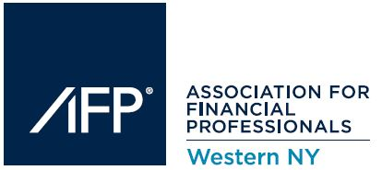
The AFP of Western New York presents its
2019 December Lunch Meeting

Sponsored by:
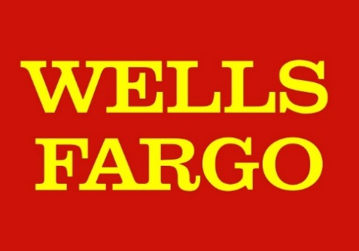
December 11th, 2019
Located at:

Ballroom 384 Event Center at City Grill
384 East Ave, Rochester, New York, 14607
TEL: 585-325-2489

THE ASSOCIATION FOR FINANCIAL PROFESSIONALS OF WESTERN NY
The Association for Financial Professionals of Western New York is a non-profit, educationally oriented organization, which provides a forum for the active and open exchange of concepts and techniques related to the practice of cash and treasury management. Today’s membership represents a wide cross section of local industry professionals. Membership is open to individuals from businesses and non-profit organizations, financial service vendors and banks. A free flow of ideas and information is encouraged and maintained among the Association’s members.
Each year, the AFPWNY bases its education program decisions on participant response to the previous year’s programs. This process ensures that topics addressed during each seminar reflect the most prevalent issues, and that the information provided is on leading edge technologies. Conference attendance continues to flourish resulting from feedback received from attendees.
AFPWNY encourages member participation in the National Association for Financial Professionals (AFP). In addition to offering a wide range of continuing education opportunities, professional certification and industry standards programs, the AFP has become an invaluable resource for disciplines represented in organizational and corporate treasury areas. Together with affiliate organizations, AFP works to increase professional skills and to enhance the recognition and credibility of the treasury management profession.
Program Registration & Lunch: 11:30 AM – 2:00 PM
Lunch will be provided around noon. Come early, it’s a great chance to network!

Presentation: 12:30 PM – 1:45 PM

Topic: Disrupt and transform: Strategies for your new normal

Speaker: Seth Marlowe, MBA/MIS, CTP, AAP, APPSC – Wells Fargo

Session Description: “I can’t be strategic because I haven’t automated and I can’t automate because I don’t have time.” Does this describe the environment you are living in today? If so, you are not alone…

In this session we will discuss highly actionable ways to address financial automation that can create momentum to tackle the strategic initiatives of your CFO and Treasurer.

By starting with low cost, low resource technologies such as RPA and APIs, your organization can gain some quick hits, both freeing up time and starting to cultivate a data-centric mindset. These experiences and project successes are the foundation for adding on strategic projects using emerging tech like Big Data and AI.

This approach will take your organization to the next level.

Objectives:
- Learn how APIs and RPA don't have to be enterprise wide initiatives and small micro projects can be the launching pad for larger and broader projects.
- Learn how these tools can help you address your organization's Big Data and help cleanse it for AI-readiness
- Learn how AI can improve processes both operational and strategic in your organization.

Speaker Information:

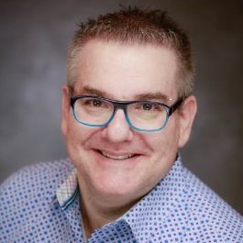

Seth Marlowe, MBA/MIS, CTP, AAP, APPSC
Senior Vice President, Strategist
Insights Consulting Group; Treasury, Merchant & Payment Solutions
Wells Fargo

Seth Marlowe is a Senior Vice President and Strategist with Wells Fargo’s Treasury Insights Consulting Group. He is a thought leader on technology, data, and innovation helping advance the bank and its customers into the next generation of payments. His focus is on the payments ecosystem and its technologies including: APIs, real time payments (RTP), AI, robotic process automation (RPA), blockchain, distributed ledger technology (DLT), bitcoin and other cryptocurrencies, big data, and the internet of things (IoT).

Seth joined Wells Fargo in 2010 and has served in a number of roles in Treasury Management Sales and Product Management. Prior to joining the bank, Seth held treasury and consulting positions at GE, Danone, Praxair, PepsiCo and EY. Seth sits on the board of directors of the Treasury Management Association of New York and the Connecticut Association for Financial Professionals.

This Conference has been approved for up to 1.5 CTP/CCM and 1.5 FP&A recertification credits by the Association for Financial Professionals

Menu Information:

Buffet Lunch

Pre-Set:
Mixed Green Salad with Balsamic Vinaigrette
Rolls & Butter

Entrees:
Chicken Cutlets
Roast Beef
Penne with Vodka Sauce

Sides:
Chef’s Choice Vegetable
Chef’s Choice Starch

Dessert:
Ice Cream Sundae

Beverages:
Coffee Station
Soda
Hot Tea

Map to Ballroom 384 Event Center:
(Note: City Grill has recently closed but Ballroom 384 remains open)
384 East Ave, Rochester, New York, 14607

